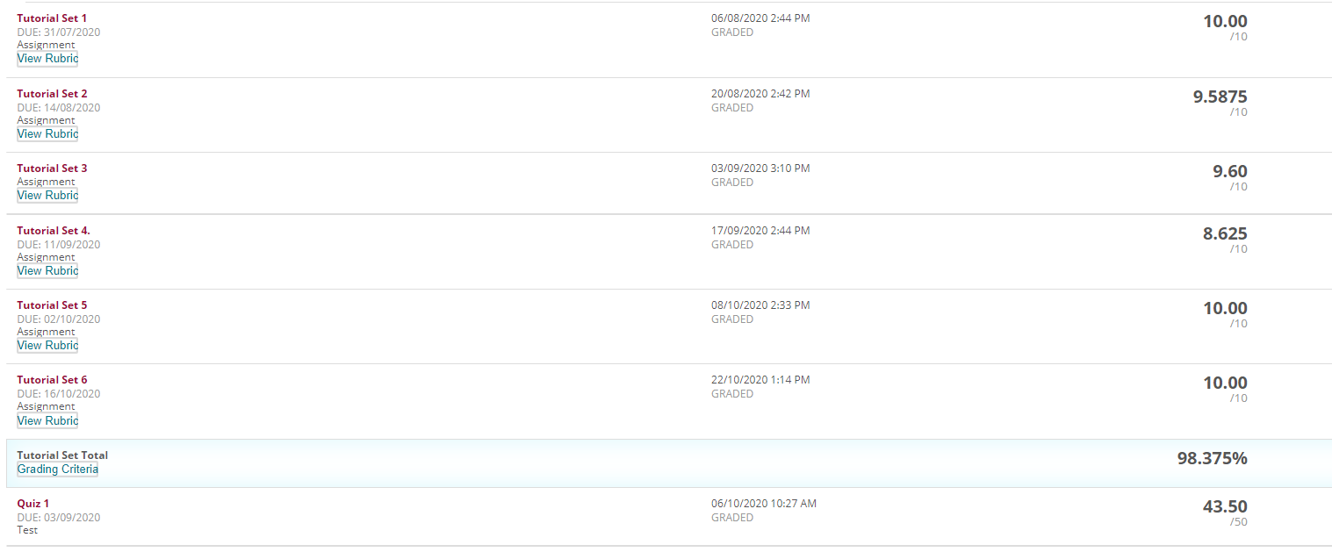  
  
The file originals contains the scores for the above; after the subject was completed, these originals were modified to improve the marks above. They should be fixed to make it 10/10 for all.